Desk Number ________

Student Number _______________________

Student Name _______________________

**School of Science and Engineering**

**FINAL EXAMINATION**

Semester 1, 2018

**CSC1001 Introduction to Computer Science**

Examination Duration: 120 minutes

Reading Time: 10 minutes

This examination has __3__ questions.

**Exam Conditions:**

This is a FORMAL Examination

This is a RESTRICTED OPEN BOOK Exam. Maximum of one (1) sheet of handwritten notes double sided are permitted

**Materials Permitted In The Exam Venue:**

Maximum of one (1) sheet of handwritten notes double sided are permitted. **NO OTHER MATERIALS PERMITTED**

Any calculators without the functionalities of programming and file storage are permitted.

**Materials To Be Supplied To Students:**

1 × 12 Page Answer Booklet

Question 1. (15 × 2% = 30%)

Pick the correct option in each of the following sub-questions. Note that only ONE option is correct.

1. Binary number 1101111.111 and hexadecimal number 2AC.3 equal to decimal numbers:
2. 111.875 and 684.1875
3. 110.85 and 683.1875
4. 111.111 and 684.3
5. 110.85 and 683.3
6. Concerning Python language, which of the following statements is incorrect?
7. Python uses an interpreter to translate source codes into machine codes.
8. In Python, reserved words cannot be used as variable names.
9. In Python, a variable has a fixed location in the memory.
10. true and false are not reserved words in Python.
11. Concerning the following program, which of the following statements is incorrect?

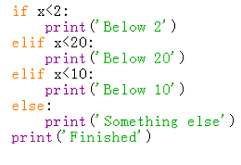

1. print(‘Below 2’) will be executed when $x=1$.
2. print(‘Below 20’) will be executed when $x=10$.
3. print(‘Below 10’) will be executed when $x=8$.
4. print(‘Something else’) will be executed when $x=20$.
5. Concerning the object in Python, which of the following statements is incorrect?
6. Every object in Python has a unique ID.
7. The type of an object is determined automatically by Python interpreter according to its value.
8. Every variable is essentially a reference to an object.
9. The ID of an object may be changed during the execution of the program.
10. Concerning the class in Python, which of the following statements is incorrect?
11. A class is a template for creating objects in Python.
12. We can create many different objects from the same class.
13. In a class, variables and functions are also called data fields and methods.
14. If two objects are created from the same class, they will always contain identical data fields.
15. Concerning private members of a class, which of the following statements is incorrect?
16. In Python, the names of private data fields and private methods start with 2 underscores or end with 2 underscores.
17. Private data fields can be accessed within a class.
18. You can define some methods to allow access to private data fields
19. Private data fields are defined to prevent potential data corruption.
20. Which of the following statements is correct?
21. eval() function is used to calculate a number expression, for example eval(2*3+1).
22. We can execute the instruction print(sin(pi/2)) after we execute import math.
23. We can open and modify a file by open(‘file1’,’r’) .
24. Python can use variables without declaration.
25. Concerning the following program, which of the following statements is incorrect?

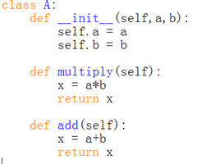

A. Class A() contains two newly defined data fields.

B. The scope of self is throughout the whole body of class A().

C. Method add() will return the sum of two data fields a and b.

D. Variable x defined in multiply() and add() are two different local variables.

9) Order the following time complexities from fast to slow:

I. 2n

II. log(n)

III. nlog(n)

IV. n3

V. n

VI. n2

1. II,V,III,VI,IV,I
2. V,II,III,I,VI,IV
3. I,II,VI,III,V,VI
4. III,II,V,VI,IV,I
5. What is the output of func(5) for the following codes:

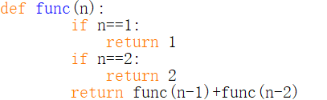

1. 6
2. 7
3. 8
4. 10
5. Concerning the following program, which of the following statements is incorrect?

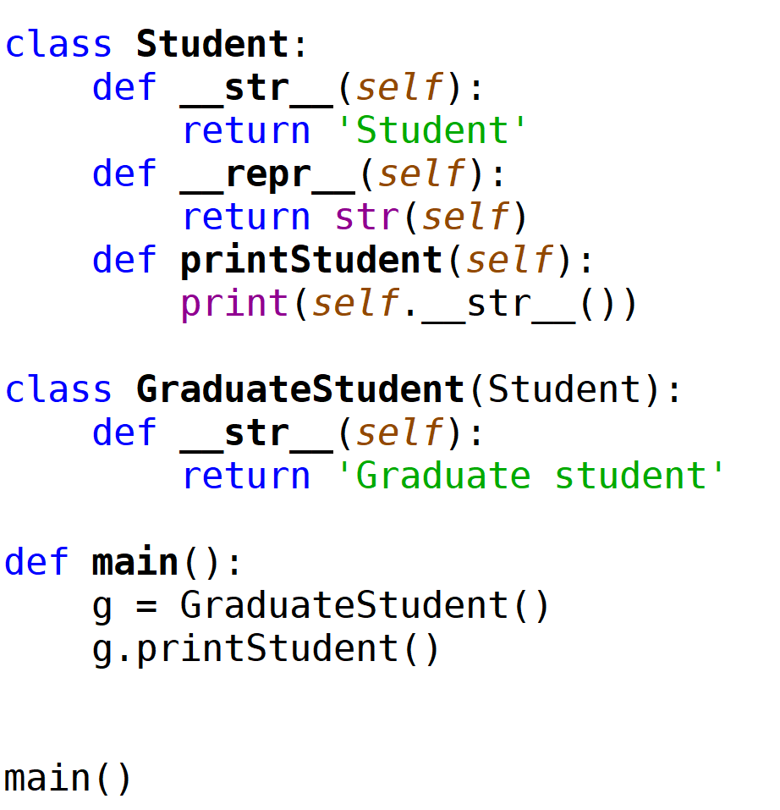

1. The output of this program is ‘Student’.
2. In class GraduateStudent(), method __repr__() will be inherited from class Student().
3. Method __str__() has been overridden in class GraduateStudent().
4. In class GraduateStudent(), method printStudent() will be inherited from class Student().
5. Concerning queue, which of the following statements is correct?
6. Data are saved sequentially in a queue.
7. Data can only be removed from the tail of a queue.
8. A queue is a collection of objects that are inserted and removed according to the last-in, first-out (LIFO) principle.
9. A queue can only be implemented based on a list.
10. Concerning stack, which of the following statements is correct?
11. A stack can be accessed based on the “first in, first out” principle.
12. More than one elements of a stack can be accessed simultaneously if necessary.
13. The time complexity of Inserting an element into a stack is linear.
14. The time complexity of removing an element from a stack is constant.

14) Concerning data structure and algorithm, which of the following statements is incorrect?

A. A data structure is a systematic way of organizing and accessing data.

B. An algorithm is a step-by-step procedure for performing some tasks in a finite amount of time.

C. The primary analysis of algorithms involves characterizing the running times and space usage of algorithms and data structure operations.

D. Space usage and running time are just dependent on the size of the input.

15) Concerning algorithm analysis, which of the following statements is incorrect?

A. When we perform algorithm analysis, we usually focus on the worst-case input.

B. The asymptotic growth rate of $40n\log{n}$ is greater than $2n^{2}$.

C. Returning from a function can be defined as a primitive operation.

D. We measure operations as a function of input size when we perform algorithm analysis.

Question 2. (10 × 4% = 40%)

Pick the correct option/s in each of the following sub-questions. Note that there may be MULTIPLE correct options for each sub-question. If your answer is partially correct, you will get 2 points.

1. Concerning the following program, which of the following statement/s is/are correct?

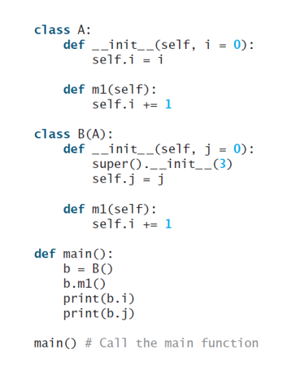

1. Class A() has no super class.
2. In class B(), the initializer of A() is accessed by calling function super().
3. Class B() has only one data field.
4. When running this program, an error will be triggered.
5. Concerning the following program, which of the following statement/s is/are correct?

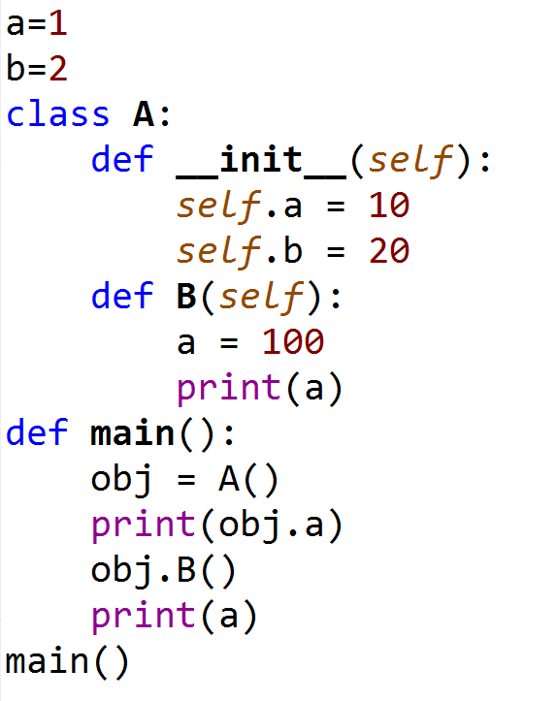

1. In this program, three different variables a have been defined.
2. Data field a of class A() can only be accessed within the class definition.
3. The value of global variable a will initially be set as 1, and then changed to 100.
4. The output of this program is

10

100

100

1. Concerning the following two programs, which of the following statement/s is/are correct?

|  |  |
| --- | --- |
|  |  |

1. The output of the first program is:

Person

Student

1. The output of the second program is:

Person

Student

1. In the first program, the getInfo() method will be overridden in class Student().
2. In the second program, the __getInfo() method will be overridden in class Student().
3. Which of the following statements is/are true?
4. import allows the use of functions defined in other modules.
5. A for loop can sometimes, but not every time, be replaced with a while loop.
6. A recursive algorithm can always be replaced with an iterative algorithm.
7. An iterative algorithm always works in linear time.

20) Concerning the binary search algorithm, which of the following statement/s is/are correct?

A. The purpose of this algorithm is to find out whether a target element exists in a given sequence of elements.

B. Binary search algorithm can be applied on an unsorted sequence.

C. The time complexity of binary search is O(log n).

D. Binary search is usually more efficient than sequential search.

21) Which of the following statements is/are correct?

A. Stack, queue, linked list and tree are all data structures.

B. A linked list is always a tree.

C. A tree is always a linked list.

D. Stack and queue can be implemented based on linked list.

1. Concerning the following programs, which of the following statements is/are correct?

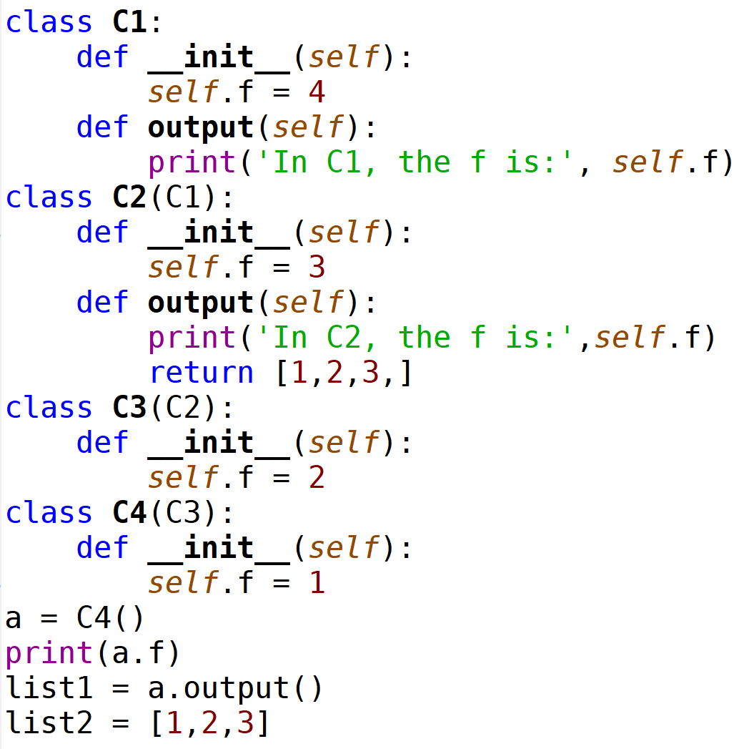

1. After executing this program, print(list1==list2) will output False.
2. In this program, the output() method defined in class C2() will be executed.
3. When running this program, an error will be triggered.
4. The output of this program is:

1

In C2, the f is: 3

1. Concerning tuple, which of the following statements is/are correct?
2. A tuple is a sequence of elements which are indexed from 1.
3. The content of a tuple can be changed during the runtime.
4. Tuple is more efficient compared with list in Python.
5. The following program will trigger an error.

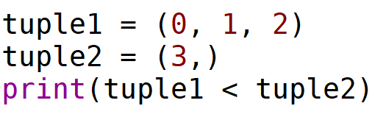

24) Concerning linked list, which of the following statement/s is/are correct?

A. For a singly linked list, each node has two references except for tail.

B. For a doubly linked list, header and tail both have two references, the other nodes has three references.

C. The time complexity of inserting a node at the tail of a singly linked list is constant.

D. The time complexity of removing a node at the tail of a singly linked list is constant.

25) Concerning a binary tree, which of the following statement/s is/are correct?

A. In a binary tree, each node contains three references.

B. In a binary tree, some nodes have one child.

C. Each child node is labelled as being either a left child or a right child.

D. A binary tree is proper if each node has either one or two children

Question 3. (4% + 4% + 7% + 7% + 8% = 30%)

Answer the following questions.

* 1. Concerning the following program

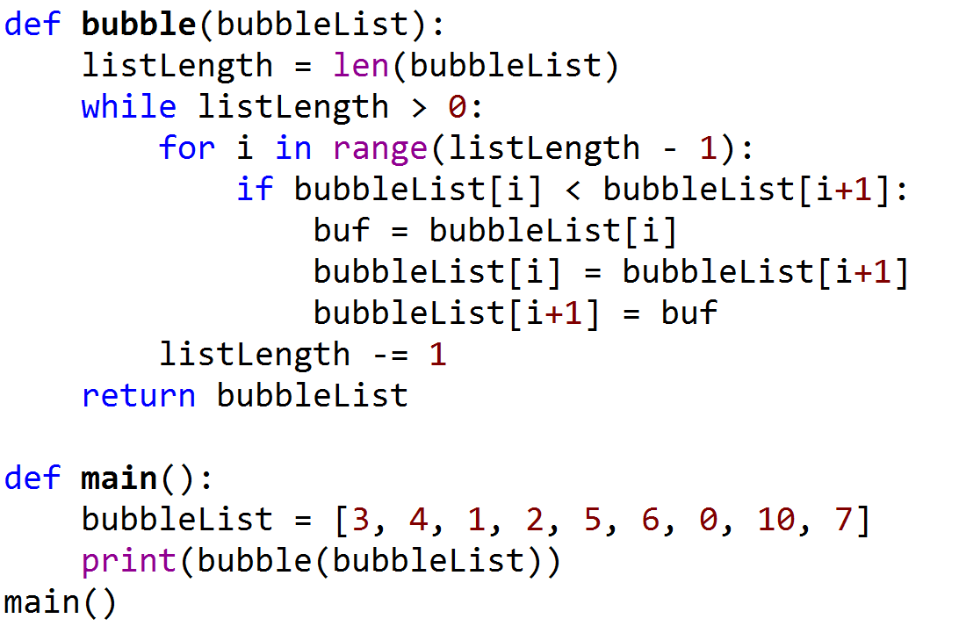

Answer the following questions:

1. What are the outputs of this program?
2. What is the time complexity of this sorting algorithm?
   1. Concerning the following program

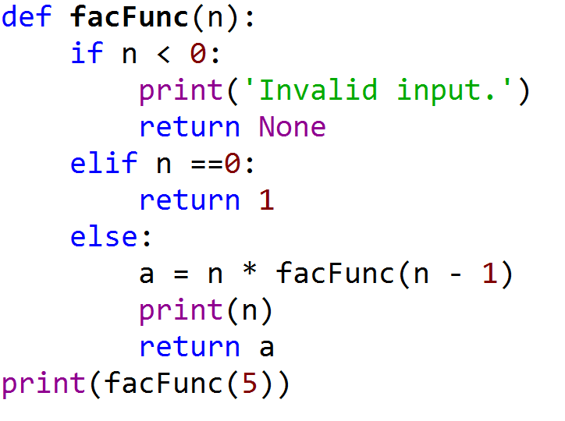

Answer the following questions:

1. How many times function facFunc() will be called in total?
2. What are the outputs of this program?
   1. Write a function which takes two inputs x and n, and outputs . This function should be a recursive function and have a time complexity of O(log n).
   2. Write a function to define a class to implement a simple stack. The operation of data obeys the First-In-Last-Out principle. The main object methods are put(item): to push the data in the stack; get(): to fetch a data from the stack; isEmpty(): to check the status of the stack.
   3. Concerning the following program, and assume that input t will be a reference pointing to the root of a binary tree.

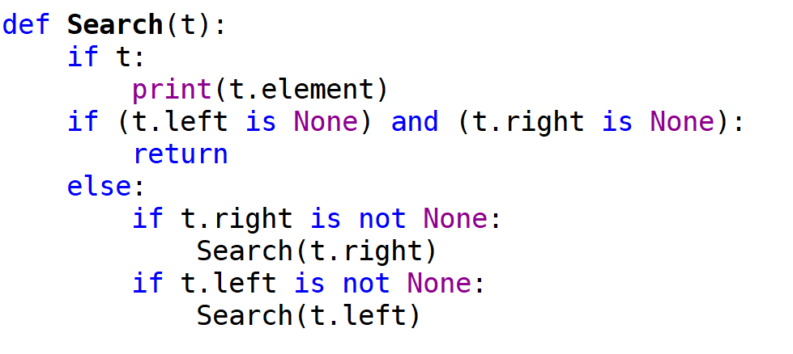

Answer the following questions:

1. Which algorithm is implemented in this function?
2. What is the time complexity of this algorithm?
3. Is this function a linear recursive or multiple recursive function?
4. If input t is referencing to the root of the following tree, what would be the outputs of this function?

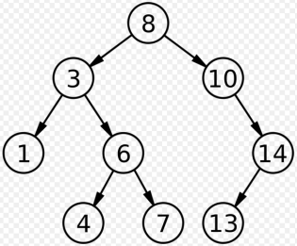

**END OF EXAMINATION**